FABI

The Flexible Assistive Button Interface

User Manual



# Preface

The Fabi Graphical User Interface (GUI) is a software application intended for use in conjunction with the Fabi device, which is an open source Assistive Technology module developed by the AsTeRICS academy project (see <http://www.asterics-academy.net>).

The Fabi (flexible assistive button interface) device allows control of a computer’s mouse cursor as well as typing desired keyboard keys for people who cannot use standard computer input devices. The Fabi Interface can be actuated via a dedicated buttons, momentary switches or self-made electrical contacts.

This user manual includes a description of “do-it-yourself” low tech hardware components for the Fabi device and a description of the Graphical User Interface for the configuration of the different functions of the Fabi Interface – as well as explanations of how to use those features. The Fabi GUI does not require prior installation, and a configured Fabi module can be used on any computer without installation of special software as well, because the Fabi module behaves exactly like a standard mouse and keyboard which is plugged into the computer.

All software and hardware plans are open source and we took care to use the most affordable components available on the market to establish the functionalities – making Fabi the cheapest flexible assistive button interface we know !!

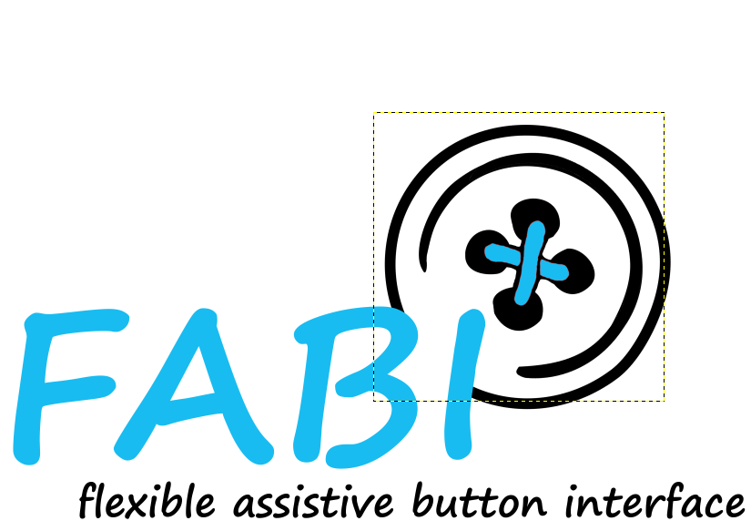.

# Contents

Preface 2

Contents 3

Hardware 4

First Steps 4

Switch 7

Connection from microcontroller to switch 10

FABI Box 12

Software 16

Software Installation 16

The User Interface 19

Features- Alternative Actions 25

# Hardware

The setup of the FABI interface for computer control is easy ! This user manual provides some ideas how to build your own alternative input devices using FABI, using creative low tech solutions.

## First Steps

In the following, some materials which you need for the different setups are listed. Before you start the actual work, please read the short soldering introduction to be prepared for the next steps

#### Material

|  |  |
| --- | --- |
| **Microcontroller**  The microcontroller is the “brain” of the FABI interface. It looks which buttons a user presses and creates the desired/associated mouse- or keyboard activities ! | * Arduino Pro Micro (or clone)  – or alternatively Teensy 2.0++: |
|  |  |
| **Switches** |  |
| Most simple: connecting two wires | * 2 switch wires (black and color) |
| Low tech switch from paper | * Piece of cartoon * Copper foil/ aluminum foil * 2 switch wires (black and color) |
| Re-Using existing switches | * 2 switch wires (black and color) * External switch (re-used from a device, light switch, etc.) |
| **Connection from microcontroller to switch** |  |
| via simple wires / jumper wires | * Prototyping-Breadboard |
| Stereo cable and jack plugs  (this is compatible to off-the-shelf assistive switches) | * Stereo cable * Jack plug |

**Material for building and soldering your own FABI Box:**

|  |  |
| --- | --- |
| **Basic equipment for soldering:** | * Solder * Soldering Iron * Switching wire * Robust pad * Pliers (for cutting, strip isolation) * Vice |
| **FABI-Box** | * Plastic Box (small black box) * Drill * 6 Jack Plugs * 1 Microcontroller (Teensy clone) * Switch wirer * Copper wirer * Double side tape |

#### Basic of Soldering

For a working electronic circuit we need to connect the single parts together, therefore we use a soldering iron.

The usage of a soldering iron is easy if you pay attention to a few things:

**Safety Rules:**

* **Never touch the tip of the soldering iron**- it gets hot enough to melt solder which is over 200^C!
* **If you use solder with lead, pay attention that it is not touching your skin and that you do not inhale it**- Lead is poisonous
* **Put the soldering Iron always back into its stand**
* **Always pay attention to what you are doing**!

1. Hold the soldering iron in your dominant hand (like you would hold a pencil). In your other hand you hold the solder
2. Touch the cleaned tip the lead solder and the part where you want to connect something
3. Add about 1mm to 3mm of solder under the tip
4. Add the other part you want to connect with the part one

|  |  |  |
| --- | --- | --- |
|  |  |  |

Figure 1: Basic steps of soldering

#### Microcontroller

In our samples we used an Arduino Pro Micro clone for circa US-$ 4,50 !. How to install and connect the microcontroller is described in the Software section.

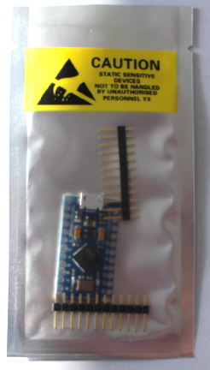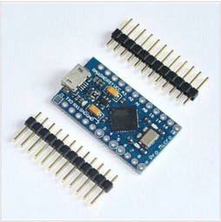

Figure 2: example of Arduino Pro Micro clone which can be used (4,50 $), http://www.aliexpress.com/snapshot/6508733198.html?orderId=65920185657484

The microcontroller has a USB-Port where it can be connected to any computer (Windows, Mac, Linux). Wires can be connected to the different pins of the microcontroller via a soldered connection or by using a breadboard (figure 3)

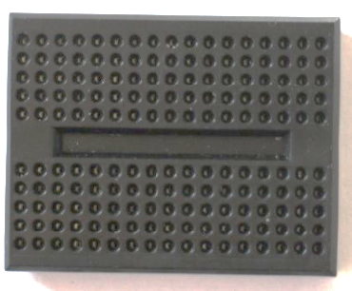

Figure 3: breadboard

**For a correct switch-connection we need one wire which is connected to the ground potential (0 volts, labelled as“GND”) and another wire connected to a certain PIN where the microcontroller then receives a signal when the switch will be pressed (See figure4)**

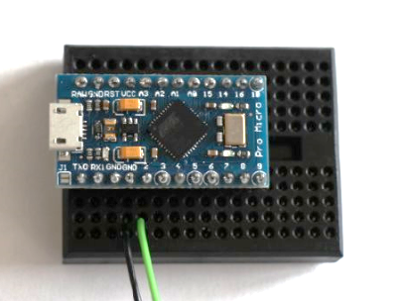

Figure 4: How to connect wires with microcontroller, here using a breadboard: black wire for GND pin, green wire for input / signal pin

## Switch

Switches are a simple method for computer control. They could create a left or right mouse click as well as many other functions. In the following, a few simple ways to create different switches are shown:

#### Simple switch with two wires

The simplest switch is built of two wires which are connected to pin and to the ground pin (GND) of the microcontroller. If the two wires do not touch each other, there is no change in the resistance between the two pins and no signal is received. If the two wires touch each other, the resistance is decreased and the microcontroller received the signal that the button was pressed.

|  |  |
| --- | --- |
| No Signal | Signal |
|  |  |

Figure 5: Simple switch made out of two wires, left picture: switch is inactive; right picture: switch is activated

#### Low Tech Switch

The function of this model works exactly like the model above but it is more user friendly.

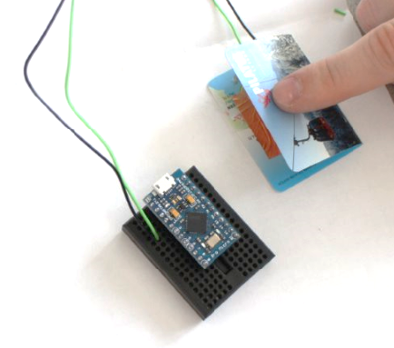

Figure 6: Low tech switch

Instead of just connecting the two single wires which are connected to the microcontroller (one to the pin and one to GND), we use copper foil (aluminum foil) and a piece of thick paper (e.g. a business card of someone you will never contact ;-) to build an accessible switch.

|  |  |  |
| --- | --- | --- |
|  |  |  |

Figure 7: material for low tech switch: left picture: piece of carton, middle picture: copper foil, right picture: switch wire

To build this switch, fold the carton in the middle like in figure 7. Afterwards stick the two pieces of foil, one of each side of the inner areas of the cartoon including a wire between cartoon and foil on each side (figure8).

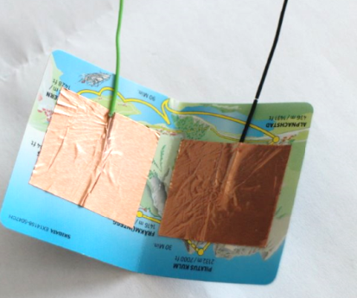

Figure 8: copper foil and the two wires stick on the inner side of the cartoon

Now connect the wire to the microcontroller like in figure 6. By pressing the upper side of the cartoon to the underside of the cartoon together that the two foil pieces can connect, the switch is activated.

#### Switch using external switch

This model has the same function as the example above.

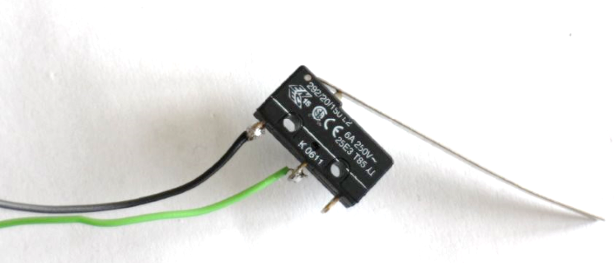

Figure 9: Switch using external switch

To solder the wires to the switch, the best is to fixate the switch in a vice. Then connect the wires to the switch using solder, shown in the picture (figure 10).

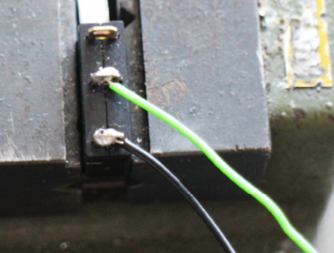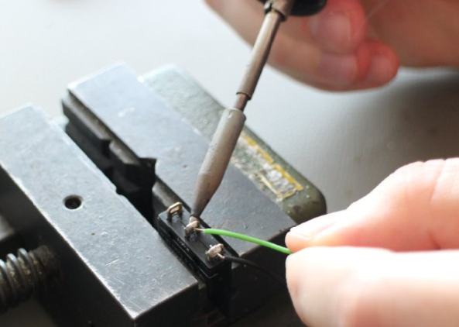

Figure 10: how to solder the wires to the switch

## Connection from microcontroller to switch

The connection via breadboard shown above is one possibility without soldering. Another possibility is to solder the single wirers directly to the pins of the microcontroller.

#### Breadboard connection

This is the simplest solution. It is especially good if you don’t want to use this construction for a long time or you want to experiment because it’s very flexible and easy to change. For long-term usage a directly soldered construction should be used because it’s more robust.

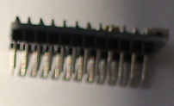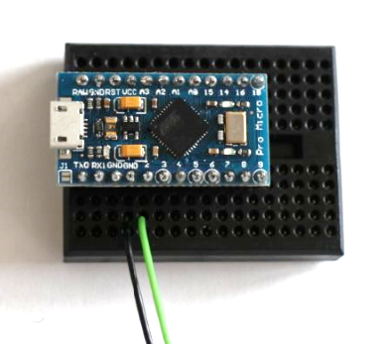

Figure 11: Wire connected to microcontroller via breadboard

For using the usage of the breadboard you first have to solder the pens to the pins of the microcontroller which can then be connected to the breadboard. Afterwards you can put you wires to the desired pin via breadboard.

**!!!**

**One important thing is to strip isolate the wires on the part which is connected to the breadboard.**

#### Directly soldered connection

This method you should use, if you want to use your device for a longer period because it is very robust and stable and can be carried around without the danger that a connection can get loose.

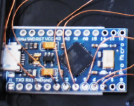

Figure 12: example, where wires are directly soldered to the single pins of the microcontroller

For soldering, follow the basic soldering introduction. Pay attention that you do not burn the device. Heat up the device via soldering iron as short as possible!

#### Connected via Jack plugs and stereo cable

In this method you directly solder the wires to the microcontroller but then you connect the wire from the microcontroller to the jack plug. With this solution you have to possibility to connect a variety of input methods to the jack plug via a stereo cable.

For this you have to directly solder one wire to the GND-pin of the microcontroller and another wire to the desired pin. The other end is soldered to a jack plug shown in figure 13. The long end of the jack plug should be connected to the ground wire on of the shorter ends to the pin-wire. Now you can easily connect any device with a stereo cable to your jack plug.

|  |  |
| --- | --- |
| Receive Pin  GND |  |

Figure 13: left picture: jack plug, right picture: stereo cable

How to add a stereo cable to your device is shown in figure 14:

|  |  |
| --- | --- |
|  |  |

Figure 14: how to solder two wires to a stereo plug

Unscrew the tip of the jack plug. Then connect the ground wire and pin wire as shown in the left pictures above using the soldering iron. After successfully finishing the soldering step, you can screw the housing of the stereo cable as shown in the right picture above.

## FABI Box

|  |  |
| --- | --- |
|  | Figure 15: FABI box |

The FABI box is a low tech device which includes one microcontroller and 6 jack plugs which can connect 6 different switches to the microcontroller via pin 2, 3,4,5,6 and 7. This device can be perfectly used with the assistive button interface software where you can choose between different alternative computer control functions explained in next chapter “software”.

|  |  |
| --- | --- |
|  | The first step to build a FABI box is to mark the drill holes for the 6 jack plugs (long side of the box) and the USB connection (short side of the box).  It is important that the single jack plugs are far enough away from each other that they do not disturb each other. The distance between two plug holes should be at least 10mm. Pay attention that the holes are in the middle of the box! |
|  | Fix the box with the vice |
|  | With a pointed punch and a hammer the holes which should be drilled are marked for an easier handling with the big drill |
|  | After the preparation explained above, make the holes (6mm) for the jack plug and the USB cable carefully with the drill  But before using the drill, please read the user manual carefully!  Pay attention to your body especially the fingers! Always use the vice while working with the drill |
|  | Now the box should have 6 holes for the jack plug and one hole for the USB cable |
|  | Remove all disturbing plastic elevations inside the box |
|  | Strip the isolation of a switch cable piece (with the length of the box) |
|  | Then you can start to screw the jack plugs in their single holes and connect them with the strip isolated switch cable (ground connection) at the longer end.  (put the switch cable through the small holes in the longer end of the jack plug) |
|  | Solder the switch cable and the long ends of the jack plugs together  (for a good electric connection and to be sure that it do not fall apart) |
|  | Now it is time to connect the single pins to the jack plugs  For this a wire out of copper is used which is very flexible and cannot brake easily.  For a better electric connection it helps to burn the end of the wire which is connected to the jack plug or to the microcontroller with the lighter that the isolating layer is 100% removed |
|  | Cut pieces of short copper wire and connect the single pieces to a pin (2-7):  First fill the pin hole on the microcontroller up with solder then heat the solder in the pin hole again and add the copper wire.  Attention it takes about one second till the solder is tight again; therefore you have to work fast and precise!  Then connect the copper wire from each pin to a jack plug (smaller end)  One copper wire is used to connect the switch wire which connects the ground connection of each jack plug with a GND pin of the microcontroller |
|  | In the end your result should look like the picture on the left side every pin is connected to one jack plug end and the ground connection is also connected to the microcontroller  Now you can screw the cover to the box and download the software |

Figure 16: User manual, how to build a FABI box

# Software

## Software Installation

The first step is to download the Software package for the stand alone from the Internet:

**https://github.com/asterics/AsTeRICS/tree/master/CIMs/StandAlone_Modules/Fabi2**

Now you have to connect your microcontroller via USB port and open the FabiWare.ino file and program your microcontroller (the single steps are explained in the next pages)

For the teensy clone used here, you need a micro USB cable (figure 17)

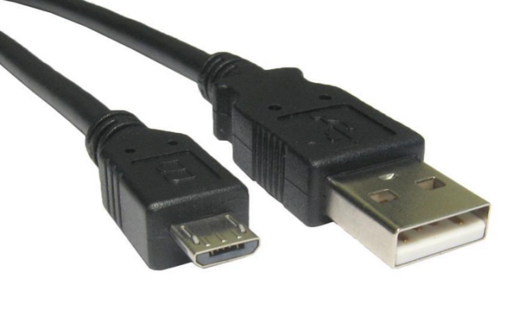

Connect this end to a USB port in your computer

Connect this end to the Fabi Device

Figure 18: Micro USB cable

After making sure that the device is securely connected to the computer, you may check if the device’s COM port is successfully detected. The detection might take a couple of seconds.

To check if a COM port is detected, go to Control Panel on your computer, and select Device Manager. A window similar to the one below should be opened:

Figure 19: How to find the right com port

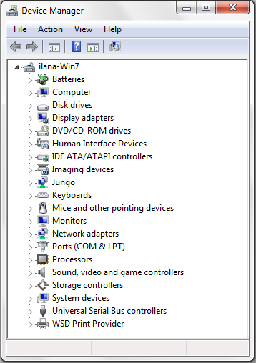

The COM port for your Fabi device should be here. You can click on “Ports” to extend the list of ports connected to your computer.

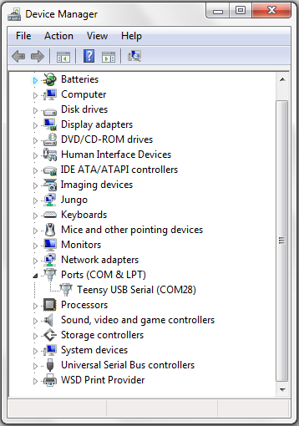

The port name is shown here. In this example it is “COM28”; however the number is arbitrary and gets automatically selected by your computer.

Figure 20: How to find the right com port

If you see a COM port as in the example above – congratulations!

You are now ready to use the Fabi GUI.

To program your microcontroller you need to remember the com port number as described above. Define your Serial Port: Tools-> Serial port-> Com Port number from above (figure 20).

In the next step you have to choose the right driver: Tools -> Board -> Arduino Micro. This is compatible for the Arduino Clone (Mini Leonardo Pro Micro ATmega32U4 5V/16MHz) (figure 21).

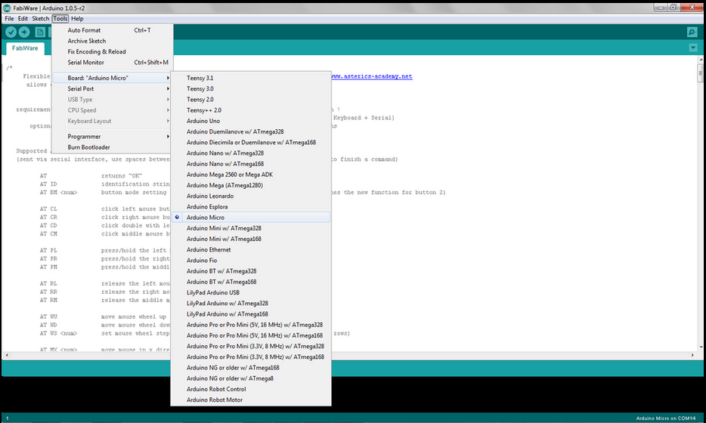

Figure 21: Set-up for the right driver: Tools-> Board-> Arduino Micro

Now open the Fabi user interface (FabiGUI.exe) which is included in the Fabi2 file.

## The User Interface

To begin using the Fabi user interface, you must open (start) the FabiGUI.exe file.

After opening the file, the following window will be displayed:

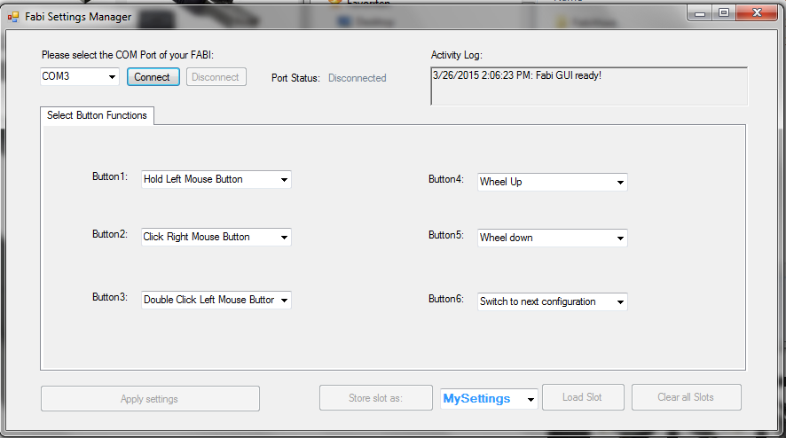

Figure 23: Fabi user interface

#### Connecting the Fabi Device

In order to be able to use the features of the Fabi GUI, the Fabi device must be connected to the application. To connect the device, follow the following steps:

1. Make sure your device is securely connected to your computer.
2. Select the appropriate COM port (communication port) in the combo box at the top of the application window. If the combo box appears empty, it means that no port has been detected. In this case, please reconnect the device and wait for the COM ports to be updated, and then click on the drop menu to refresh the COM port list or restart the application.
3. Once the COM port is selected, click the Connect button on the right hand side of the combo box. When the device is connected, a confirmation message will appear in the activity log at the bottom of the application window, like the example below:

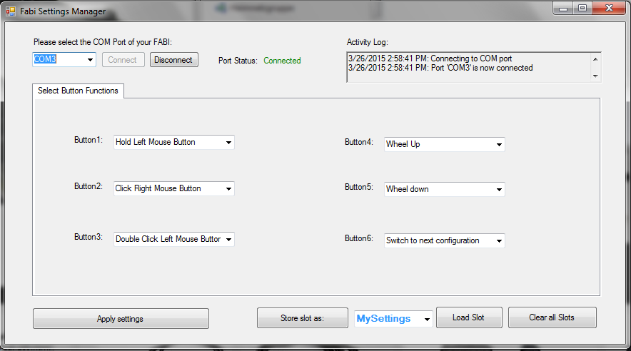

Figure 24: Program connected to the right port of the microcontroller

#### Port Status

The port status is located at the top right hand corner of the application window. It displays whether the device is currently connected or disconnected from the user interface. The functions of the user interface may only be used if the port status is “connected”.

#### Activity Log

The activity log is located at the bottom of the application window. It provides messages in accordance to the use of the application.

#### Applying Settings

The settings selected for the various features will not be automatically changed. After you are done fine tuning the features of the Fabi user interface to your liking, you may click “Apply settings”. Once the settings have been applied, you will receive a confirmation message in the activity log, and you will be able to use the Fabi user interface with the new configuration.

#### Saving, Loading and Clearing Slots

If you have selected Button Functions settings that you would like to use again, you may save them as a memory slot, which you can later re-load and use.

When you save a new slot, you can first give it a name that will help you remember the configuration. To write in a new name, click on the click on the drop down menu on the right of the “Store Settings as” button.

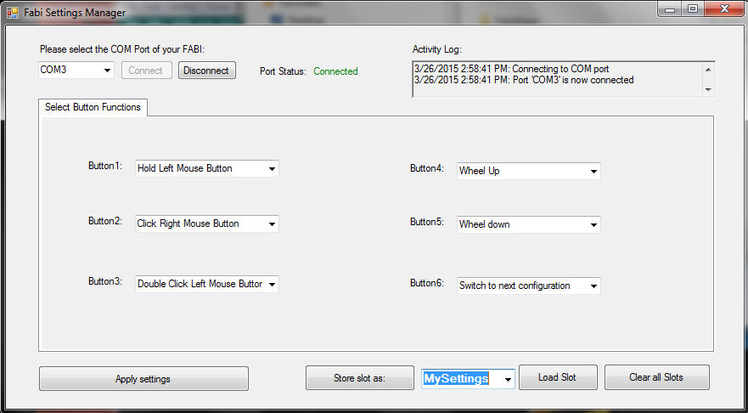

Figure 25: Saving, Loading and Clearing Slots

Clicking will highlight the default text, as seen above. You may now the type the new name, which will replace the default text. After typing in the new name, click the “Store Settings as” button.

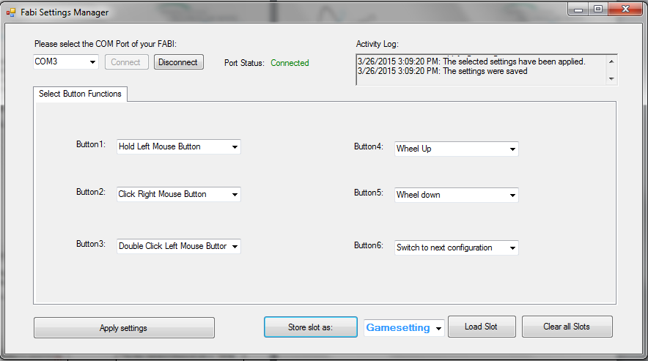

Figure 26: How to rename and store desired settings of single button functions

Click this button to save the configuration under the name entered in blue on the right

The new name in this example is “Game settings”, which can save the settings for the required input actions when playing a particular computer game

When your new configuration is saved, confirmation messages will appear in the activity log:

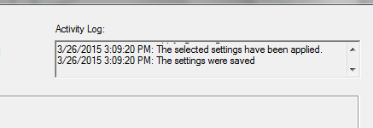

Figure 27: confirmation message, that new configuration is saved

When you store the settings, there is no need to apply them first, because the “store settings” button applies the settings before saving the configuration (as you can see in the activity log shown in the above image). You can save more than one configuration of settings. To save multiple setting configurations, simply change settings for the new configuration and repeat the above steps to save the new setting configuration under a different name.

When you wish to use a particular configuration of the settings which you have saved before, expand the drop down menu by clicking the black arrow and choose the desired configuration. Once you have chosen it, click on “Load Slot”, and the saved settings will appear in the application.

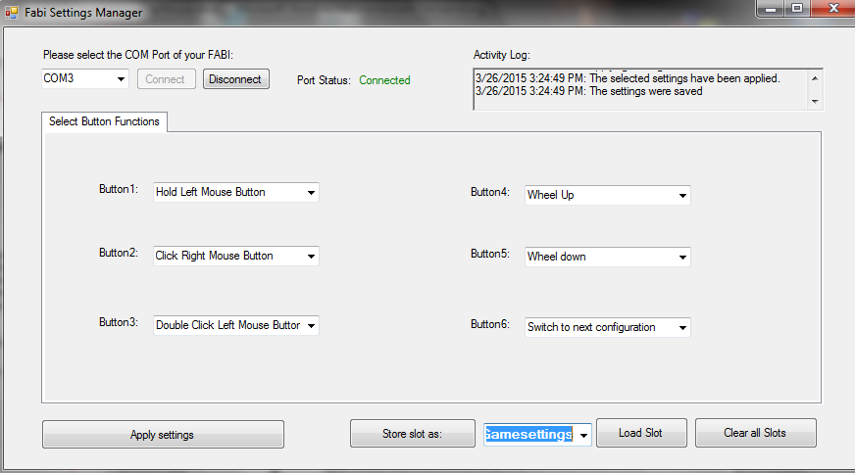

Click “Load Slot” to begin using the saved configuration

Click here to expand the drop down menu and select the slot with the desired configuration

Figure 28: Load and select desired configuration

When a slot is loaded, you will receive the following confirmation messages in the activity log:

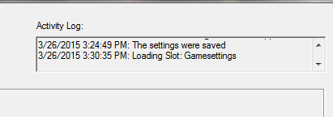

Figure 29: confirmations message by loading a slot

If you would like to change the settings of a saved configuration, follow the next steps:

1. Load the slot (as described above) that you want to change.
2. After the slot is loaded, change the settings as you wish.
3. Click “Store settings as” to re-save the changes to the slot. You will receive the same confirmation messages in the activity log as when you save a slot for the first time (see image in previous page).

If you no longer wish to use any of the saved configurations, you may delete all of them at once by clicking “Clear all slots”.

## Features- Alternative Actions

In the Fabi user interface, you have different actions option: You can choose from different computer input control methods starting from “right mouse click” to several functions like “wheel up” or “Hold Mouse Button” In the following chapter the single alternative actions are explained.

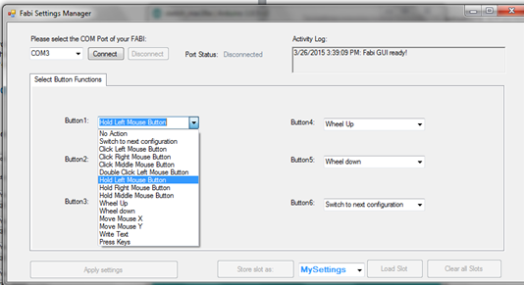

Figure 30: different alternative actions of the Fabi GUI

#### No action

If “No action” is selected from the function menu, then no action will be done when executing a particular movement. For example, consider the following case:

#### Switch to next configuration

This action is only relevant if you saved multiple Fabi setting configurations to memory slots . Once you have multiple configurations saved, you can assign the action of switching between the configurations saved on different slots in the application.

#### Click left/middle/right/ middle mouse buttons

With this function you can simulate a left/middle or right mouse click with the selected button

#### Double click left mouse button

Double clicking the left mouse button may be necessary in cases such as opening a file. However, producing a double click with the regular click mouse button function may not be convenient, so you may assign a double click of the left mouse button instead.

#### Hold left/middle/right mouse buttons

The click mouse button options imitate a quick mouse click, however sometimes it is necessary to continue pressing a particular mouse button (for example, when dragging a file, continuously pressing the left mouse click is necessary). For this purpose, the Fabi user interfaces application allows assigning a button holding function to one of the stick movement directions.

#### Wheel up/down

The options “Wheel up” or “Wheel down” emulate a scroll wheel, otherwise known as the mouse wheel. The picture below displays an example of a scroll wheel. Triggering the “Wheel up” option results in upwards scrolling, while “wheel down” results in downward scrolling.

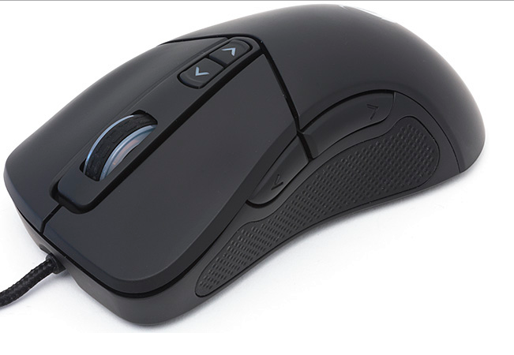

Scroll wheel on a typical computer mouse; allows scrolling in both directions

Figure 31: Computer Mouse with wheel up/down function

#### Mouse move X or Y

The cursor movements on the computer screen occur in both vertical and horizontal direction, where vertical movements are movements across the X axis and horizontal movements are movements across the Y axis. The “Move mouse X” and “Move mouse Y” emulate computer mouse movements and when triggered they result in mouse movements in the selected axis

These two options also require a speed parameter to indicate how quickly the cursor should move in each case. The input field for the speed parameter appears once the mouse move option is selected.

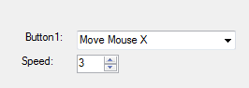

Speed parameters for each of the mouse movement options. Press the upwards or downward arrows to increase or decrease the speed, or press on the number to type in the speed manually

Figure 32: Screenshot of "Move Mouse X" action, the same principle is valid for Move Mouse Y

#### Write text

The “Write text” option allows you to type a particular text excerpt each time you perform an action (for example, write “Hello” when you press the button).

When you select “Write text”, a blank text box will appear under the drop down menu as shown below: Click on the text box and type the desired text.

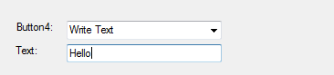

Write text here

Figure 33: Screenshot of "Write Text" action

In this example, “Hello!” will be written each time the button is pressed

#### Press Keys

The “Press Keys” function allows you to perform a selected key command by pressing the button.

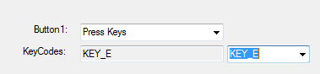

Choose desired key

Figure 34: Screenshot of "Press Key" action

In this example, “E” will be written each time the button is pressed.